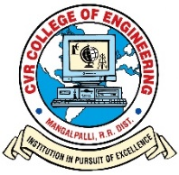**CVR COLLEGE OF ENGINEERING**

(An UGC Autonomous Institution with NAAC ‘A’ Grade, Affiliated to JNTUH)

Vastunagar, Mangalpalli (V), Ibrahimpatan (M), R.R. District, Telangana

Ph. No:91-8414 – 661601, 661675

**DEPARTMENT OF ELECTRONICS AND COMMUNICATION ENGINEERING**

**INDUSTRY ORIENTED MINI PROJECT CONSENT FORM**

ACADEMIC YEAR 2020-2021

|  |  |  |  |
| --- | --- | --- | --- |
| CLASS: III Year ECE | | | SECTION: D |
|  |  |  |  |
| **S.No** | **Name of the student** | **Register number of the student** | **Batch no** |
|  |  |  |  |
| 1. | R SRIRAM CHOUDARY | 18B81A04N9 |  |
| 2. | M UDAY PRANEETH | 18B81A04P2 | D14 |
| 3. | B PRAVEEN KUMAR | 18B81A04M0 |  |



**Domain of project work: Image Processing**

**Title of project work:**

**THEFT PREVENTION IN MALLS & SUPER MARKETS**

**USING IMAGE PROCESSING**

Name of the supervisor: Signature of the supervisor: